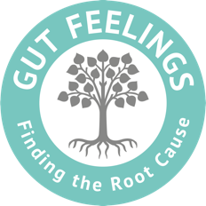

Testing stomach Hydrochloric Acid (HCl) levels

First thing in the morning, on an empty stomach, before eating or drinking anything, put ¼ (a a quarter) TEAspoon of Bicarbonate of Soda (you can usually get this from the baking section in the supermarket – note that it is not baking powder) in a glass with 250ml of slightly warm water.

Drink the mixture. If there is sufficient HCl in the stomach, there is usually a belch/burp within 2 minutes, this is caused by carbon dioxide gas created by a chemical reaction between the acidic HCl and alkaline Bicarbonate of Soda.

Please note that this is not a conclusive diagnostic test, but may be an indication of levels and is taken into consideration alongside symptoms.

Less than 1 minute: possible high HCl level
1 – 2 minutes: normal HCl level
2 – 3 minutes: normal to slightly low level
3 – 5 minutes: potential hypochlorhydria (low level)
5 minutes plus: achlorhydria (potentially very little HCl).

Repeat the test for 3 days in a row and record the burp timings.

Here is a short video clip that shows how it is done https://www.youtube.com/watch?v=CTQy-dG_h5s

